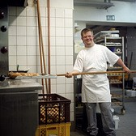

**Meet & Greet:** 6:30-7:00pm

**Meeting:** 7:00-8:30 pm

**Location:** Hayes Center (Champaign-Urbana Special Rec)

1311 W Church Street, Champaign

|  |
| --- |
| **Family Support in Job Preparation**  **Date: 1/26/2016**  Discussion will include: steps the family and supportive persons in the individuals’ lives can help do to prepare the individual for employment in the community. |
| **ABLE Act**  **Date: 2/23/2016**  Senator Bennett will come in to talk about the ABLE act and answer any questions. |
| **How Will Employment Affect Benefits**  **Date: 3/22/2016**  Janice Williams from Illinois Assistive Technology Program will be here to talk about how benefits will be effected by employment and to answer any questions. |

|  |
| --- |
| **Process of Transition**  **Date: 4/26/2016**  Hear steps are needed to help transition to working in the community and meet a family who has been through this transition. |
| **Natural Supports**  **Date: 5/24/2016**  Discussion will include: steps the family and supportive persons in the individuals’ lives can help do to prepare the individual for employment in the community. |
| **Success Stories**  **Date: 6/28/2016**  Hear success stories of those in this area that are working in the community. |

New!

### **To RSVP, please contact:**

### Michelle Petty, Phone - (217) 356-9176 x423, Email – [mpetty@dsc-illinois.org](mailto:mpetty@dsc-illinois.org)

### Hannah Sheets, Phone – (217) 621-1090, Email – [Hannah.communitychoices@gmail.com](mailto:Hannah.communitychoices@gmail.com)

**Family Informational Meetings**

**Developmental Services Center & Community Choices**

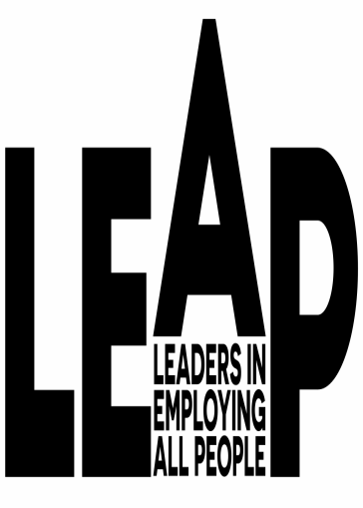

These meetings are open to individuals with developmental or intellectual disabilities residing in Champaign County, families, friends, and anyone who is interested in supporting this initiative.

Attendance at all meetings isn’t required. Whether you attend one meeting, or all of them, we look forward to seeing you there!

**Partners for Employment**, a collaboration between Community Choices and Developmental Services Center, is pleased to announce the following series of family meetings. Come and hear about the progress of the Employment First Initiative in Champaign County and how it will influence services in the future.

©2015-2016 Partners for Employment